**Multi class vehicle classifier**

--------------------------------------------------------------------------------------------------------------------------------------

**Requirements**

**1. Python 3.5.x and Pip**

**2. TensorFlow**

**Note:** For Windows users, TensorFlow only supports version 3.5.x of Python.

--------------------------------------------------------------------------------------------------------------------------------------

**How to create your own image classifier**

**1. Install Python 3.5.x and Pip**

Install for Ubuntu

Run "sudo apt-get install python-pip python-dev" in terminal.

**2. Install TensorFlow**

Install for windows

Run "pip3 install --upgrade tensorflow" in terminal.

Install for Ubuntu

Run "pip3 install tensorflow" in terminal.

**3. Validate Your Installation**

For both users, invoke python from your shell as follows:

$ python # Ubuntu

C:\> python # Windows

Enter the following short program inside the python interactive shell:

>>> import tensorflow as tf

>>> hello = tf.constant('Hello, TensorFlow!')

>>> sess = tf.Session()

>>> print(sess.run(hello))

If the system outputs the following, then Tensorflow has been successfully installed:

Hello, TensorFlow!

**4. Prepare your training data**

Training data is what you want your computer to learn, to recognize the objects in the images. There is a super convenient Google plug-in called “Fatkun Batch Download Image” may help us downloading amount of images at once.

**5. Place the images into different folder for each different type as they are arranged in data folder.**

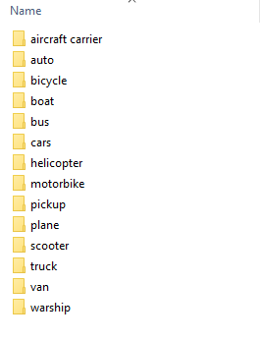

**6. Start Retraining**

At first, get the latest sample code from git TensorFlow repository. The sample code will be in "/tensorflow/tensorflow/examples/image_retraining/retrain.py"

For training type the following command in terminal

python {$your-working_directory}/retrain.py

--bottleneck_dir=/{$your-working_directory}/bottlenecks

--how_many_training_steps 500

--model_dir=/{$your-working_directory}/inception

--output_graph=/{$your-working_directory}/retrained_graph.pb

--output_labels=/{$your-working_directory}/retrained_labels.txt

--image_dir /{$your-working_directory}/${your_training_data_path}

The command I used was:

python retrain.py --bottleneck_dir=bottleneck --how_many_training_steps 2000 --model_dir=model --output_graph=retrained_graph.pb --output_labels=retrained_labels.txt --image_dir data

**Note:** Retraining will take at least 20 minutes.

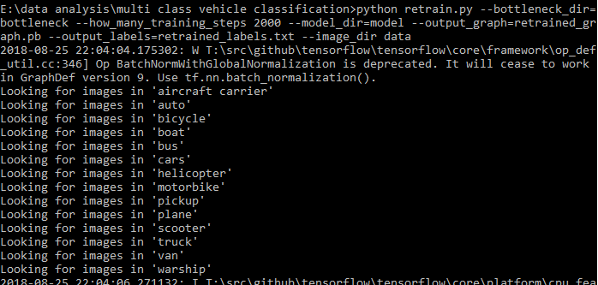

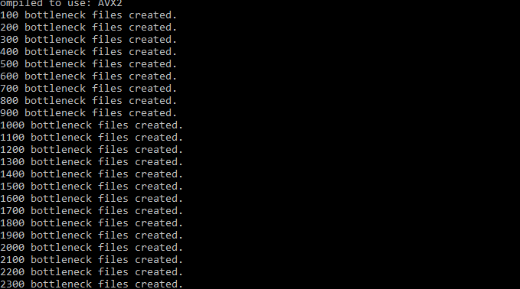

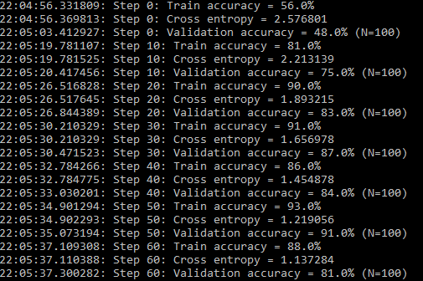

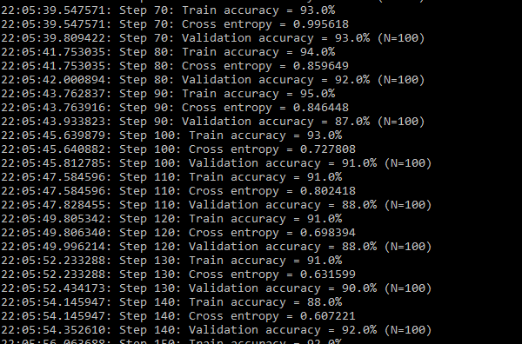

**7. Test your image classifier**

Go to your work directory and create a file called "label_image.py".

Type the following lines of code and save it.

import tensorflow as tf, sys

image_path = sys.argv[1]

# Read in the image_data

image_data = tf.gfile.FastGFile(image_path, 'rb').read()

# Loads label file, strips off carriage return

label_lines = [line.rstrip() for line

in tf.gfile.GFile("D:/tensorflow_work/retrained_labels.txt")]

# Unpersists graph from file

with tf.gfile.FastGFile("D:/tensorflow_work/retrained_graph.pb", 'rb') as f:

graph_def = tf.GraphDef()

graph_def.ParseFromString(f.read())

_ = tf.import_graph_def(graph_def, name='')

# Feed the image_data as input to the graph and get first prediction

with tf.Session() as sess:

softmax_tensor = sess.graph.get_tensor_by_name('final_result:0')

predictions = sess.run(softmax_tensor,

{'DecodeJpeg/contents:0': image_data})

# Sort to show labels of first prediction in order of confidence

top_k = predictions[0].argsort()[-len(predictions[0]):][::-1]

for node_id in top_k:

human_string = label_lines[node_id]

score = predictions[0][node_id]

print('%s (score = %.5f)' % (human_string, score))

Run the command in terminal

"python label_image.py Image_to_test_path/Image_name.extension"

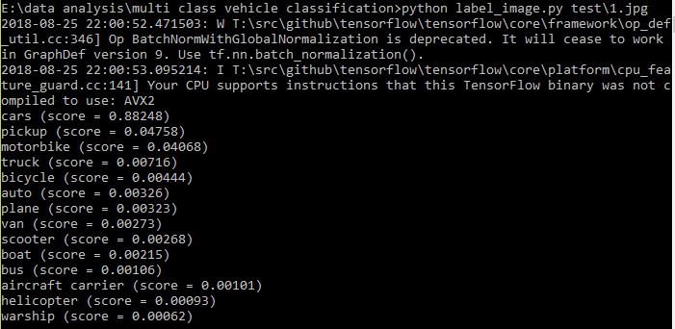

--------------------------------------------------------------------------------------------------------------------------------------

**Notes:**

1. There should be at least 50 images of each type in the dataset for proper training of the model.

2. The model may take 20 minutes to 2 hours depending on the amount of data and configuration of the machine.

3. The above is made and tested on Python 3.5.2 only.